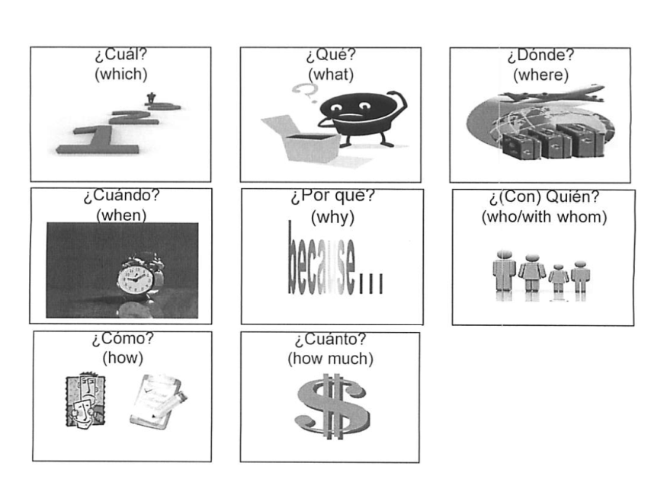**BÁSICOS: Preguntas (Words)**

**The following information adapted from: drlemon.com**

[**http://www.drlemon.com/Grammar/interrogatives.html#.UiliKdStOYM**](http://www.drlemon.com/Grammar/interrogatives.html#.UiliKdStOYM)

1. ***Accent Marks:*** Notice that the Spanish interrogatives all have **accent marks.** This is important when writing because these words have different meanings without the accent marks.

For example,

* *qué* means `what', but *que* without an accent mark on the E means `that';
* *cómo* means `how', but *como* without an accent mark on the O means `as' or 'like'.

1. ***¿Qué?* vs. ¿*Cuál?***

* ***Qué*** means "what" when looking for a ***definition****:*
* *¿Qué es esto?* What is that?
* *¿Qué haces?* What are you doing?
* ***Cuál*** means "which" but it also can function as "what” to identify something from a ***selection***:

|  |  |
| --- | --- |
| *¿Cuál es su nombre?*  *(selection)* | What is your name?  ("Of all the names there are, ***which*** is yours?") |
| *¿Qué es su nombre?*  *(definition)* | What kind/type of name do you have?  (Irish? English? Cuban?) |

* ***Usually\**, the Rule of Thumb is to use *Qué + Nouns* and *Cuál* + *Verbs*:**

|  |  |
| --- | --- |
| *¿Qué* ***materias*** *estudias este semestre?* | *¿Cuáles* ***son*** *tus clases este semestre?* |

*Exception to Rule of Thumb: You may hear in some Latin American countries the use of both with nouns in conversation.